Homework for Chapter 6: Causal Diagrams

1. In a conversation with your friend, you mention a study you read that found that being tall causally makes you more likely to earn above $100,000 per year. Your friend says the study must be wrong, since they know several tall people who make much less than that, and several short people who do earn that much. Does your friend’s reasoning make sense or not, and why?
2. Consider the below diagram, which reproduces Figure 6.3:  
   Diagram

   Description automatically generated  
   In this diagram...
   1. Which variables have a direct effect on Money?
   2. Which variables have an indirect effect on Money?
3. You are interested in the question “Does reading Harry Potter as a child make you read more as an adult?” and draw the diagram below.   
   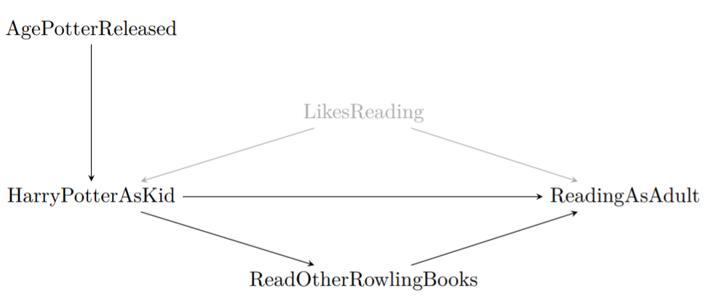
   1. What direct effects should be included when trying to answer your research question of interest?
   2. What indirect effects should be included when trying to answer your research question of interest?
   3. What is a likely alternative explanation of why we might see a relationship between reading Harry Potter and reading more as an adult?
4. The figure in Question 3 has LikesReading included as an unobserved variable. In a few sentences each, explain:
   1. Why do we bother to include variables on our diagrams if we can’t observe them?
   2. Why might we think that LikesReading is an unobserved or latent variable?
5. Consider the research question “do government fire-safety advertisements reduce forest fires?”.
   1. Draw a causal diagram with these features: (a) ForestFires is caused by FireSafetyAds and ParkRangers (who can help catch fires early and put them out). (b) Both FireSafetyAds and ParkRangers are caused by GovtBudget (the government has to pay for this stuff!). (c) GovtBudget is caused by TimeSinceLastFire— a recent fire might get more money sent to the parks department.
   2. Suggest one omitted arrow or variable that should be on the diagram.
6. Think of a research question in your field/major.
   1. Sketch out the possible data generating process.
   2. What is the cause of interest? The outcome?
   3. What other variables are in play?
   4. Draw a causal diagram depicting the relationships between all of the variables?
   5. Can there be any unobserved or latent variables? Include them in the diagram.
7. Consider this research question: Does the inclusion of “free shipping” cause people to buy items from an online store more?
   1. List six variables that should be included in a causal diagram.
   2. Is it feasible to collect data on all the variables that you listed in part a? Can the variables be measured easily?
8. Define *causality*. In a few sentences, why is causality interesting and important?
9. Which of the following describes a representation of a data generating process (DGP) including variables in that DGP and the causal relationships between them?
   1. Causality
   2. Direct and indirect effect
   3. Latent variable
   4. Causal diagram